**Physics Mirror Review**

**Use the word bank to complete the fill in the blank. Words may be used more than once or not at all.**

**Center of curvature**

**Concave**

**Converges**

**Convex**

**Curved**

**Diffuse**

**Diverges**

**Focal point**

**Focal**

**Incidence**

**Incident**

**Law of Reflection**

**Plane**

**Radius**

**Real**

**Reflect**

**Reflection**

**Specular**

**Straight**

**Virtual**

1. The three types of mirrors are: _________________, ____________________ and ___________________.
2. The two types of spherical mirrors are: _________________ and ___________________.
3. A _________________ mirror forms both real and virtual images.
4. A _________________ mirror curves inward.
5. A _________________ mirror curves outward.
6. Point C is known as the _________ _____ _________. Therefore, this point is always in front of the curved area of the mirror.
7. The measurement of C is the same as the _________________.
8. The radius of curvature is twice the ___________ length.
9. F is the __________ __________ of the mirror.
10. A _________________ mirror always forms an image that is the same size as the object.
11. An image from a _______________mirror will always appear smaller than the object.
12. In a Fun House, a mirror that makes you look upside down would have to be a ________________ mirror.
13. A __________________ mirror is used for the side mirror on a car.
14. Light rays will _____________________ when they hit a mirror.
15. A ________________ mirror can produce an image that appears larger than the actual object.
16. The light that approaches the mirror is known as the _______________________ ray of light.
17. The point in front of the mirror where the reflected rays meet is called the ______________ point.
18. A __________________ mirror is also known as a converging mirror.
19. A __________________ mirror is also known as a diverging mirror.
20. The angle of _____________________ is always equal to the angle of ___________________.
21. The statement in number 20 is known as The ______ ____ ____________________.
22. A ______________________ mirror is used for security purposes in stores.
23. A ______________________ image cannot be obtained on a screen/paper.
24. The brain interprets a light wave as traveling in a _____________________ line.
25. Only ___________________ rays may be extended behind the mirror.
26. If light hits a rough surface, ____________________ reflection occurs.
27. If light hits a smooth surface, __________________ reflection occurs.
28. A __________________ image is always upright.
29. A __________________ mirror is used by interior decorators to create the illusion of depth.
30. A convex mirror ___________________ light rays.

**Short Answer**

1. You are given three mirrors of equal size. How can you identify which is the plane, convex and concave mirror?
2. List the four characteristics of an image formed by a plane mirror.
3. Explain how to draw a ray diagram for a concave mirror when the object is placed at C and list the LOST characteristics.
4. Explain how to draw a ray diagram for any convex mirror and the resulting LOST characteristics.
5. Explain how to draw a ray diagram for a concave mirror when the object is in front of f and list the LOST characteristics.
6. An object is located at the focal point of a concave mirror. Describe the image.
7. Why is the distance of a virtual image always a negative value?
8. What does a negative magnification indicate?
9. Explain how to measure the angle of incidence.
10. What items were used as mirrors before modern mirrors were created? Why did these items work?
11. What is the purpose of the glass of a modern mirror? The silver backing?
12. If an object is located 10 cm in front of a plane mirror, the image is located ________________.
13. If the focal length of a spherical mirror is 6 cm the center of curvature is ____________.

**True or False**

1. A convex mirror always creates virtual images.
2. A plane mirror creates both real and virtual images.
3. An object placed outside of the focal point of a concave mirror forms a real image.
4. An image formed by a convex mirror is magnified.
5. The normal line is drawn parallel to the surface of the mirror.

**Multiple Choice**

1. In the diagram to the right, which letter represents the image of the object?
2. A b. B c. C d. D e. E

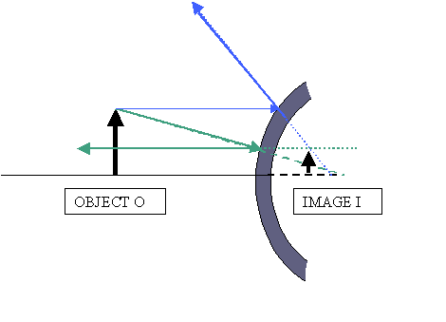

1. Which type of mirror is represented by the diagram at the right?
2. Plane b. concave c. convex d. parabolic
3. How can you tell if you are looking into a concave mirror?
4. It curves outward and the images are upright
5. It is curved inward
6. 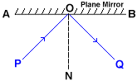You will appear inverted or upright depending on your location
7. Both b and c

**Use the diagram below for questions 4-7**

1. The line OQ is the _____________________
2. Incident ray
3. Reflected ray
4. Normal
5. The angle of incidence is given by the angle __________
6. AOP
7. QBO
8. NOQ
9. PON
10. The angle of reflection is given by the angle ____________.
11. AOP
12. QBO
13. NOQ
14. PON
15. The line ON is the ____________________
16. Incident ray
17. Reflected ray
18. Normal

**Drawing Ray Diagrams**

Draw the following situations. List the LOST for each image.

1. 1.0 cm object located 4 cm in front of a converging mirror that has a radius of 6 cm.
2. 1.0 cm object located 3 cm in front of a convex mirror that has a focal length of 2 cm.

**Problems**

1. A Star Wars action figure, 8.0 cm tall, is placed 30.0 cm in front of a concave mirror with a focal length of 10.0 cm.
2. Where is the image located?
3. How tall is the image?
4. What are the characteristics of the image?
5. The same Star Wars action figure, 8.0 cm tall, is placed 6.0 cm in front of a convex mirror with a focal length of -12.0 cm.
6. Where is the image located?
7. What is the magnification?
8. What are the image characteristics?
9. A 4.00-cm tall light bulb is placed a distance of 45.7 cm from a concave mirror having a focal length of 15.2 cm. Determine the image distance and the image size.
10. Light is incident on a flat surface, making an angle of 10o with that surface. What is the angle of reflection?