Physics Work, Power and Energy Study Guide

Vocabulary

- Elastic Potential Energy
- Energy
- Fulcrum
- Gravitational Potential Energy
- Inclined Plane
- Joule
- Kinetic Energy
- Law of Conservation of Energy
- Lever
- Mechanical Energy
- Newton-Meter
- Power
- Pulley
- Screw
- Simple Machine
- Watt
- Wedge
- Wheel & Axle
- Work
- Work energy theorem

Concept Questions
- What are the requirements for work to be done on an object? Force must cause displacement.

- Work is a ___________. A + or – sign on a work value indicates information about ______.
  - Vector; direction of work
  - Scalar; the direction of work

- What is the unit(s) for work?

- Indicate whether there is positive or negative work being done:
  - _____An eastward moving car skids to a stop. Negative
  - _____At Six Flags, a roller coaster is lifted to the peak of the first hill. Positive
  - _____A catcher puts his hand in the mitt and catches a baseball. Negative
  - _____You pick up your book bag from the floor and put it in your locker. Positive

- What is power and how is it measured? Power is the rate at which work is done; Watts

- For the following 3 scenarios, explain why work is or is not done:
- A woman preparing for a trip lifts her suitcase from the floor to the bed so that she may pack more easily. Work done, force causes displacement
- A man spends 5 minutes holding a present before hiding it on a closet shelf. No work, holding a book, no displacement.
- A student carries his book bag down the hallway. No, force and displacement are perpendicular.

7. Identify which of the pairs in each scenario illustrates more work being done:
- A boy helps a teacher by lifting a 200-N box of books 1.5 meters from the floor to the desktop.
- The same boy lifts a 500-N box of books to the same height. More force = more work
Explain your choice:

- A girl throws a 1-kg softball with a force of 50 N a distance of 25 meters. More distance = more work
- The same girl throws the softball with the same force a distance of 17 meters.
Explain your choice:

8. Identify which of the pairs in each scenario illustrates less power being generated:
- A woman pushes a cart with 95 N of force 3 m in 10 seconds.
- A man pushes a cart with 95 N of force 3 m in 13 seconds. Same work, more time.
Explain your choice:

- A 340-N student climbs the stairs in 14 seconds. Same displacement, same time, less force
- A 420-N student climbs the stairs in 14 seconds.
Explain your choice:

9. The relationship between power, force and velocity is ________P = FV__.

10. The 2 simple machines that are a modified version of the inclined plane are
______screw________________and ________wedge_______________.

- Is energy a vector or scalar? What does this indicate? What about work? Power? All scalar

- How can a person become more powerful? Do same work in less time, do more work in same time

- What two conditions must be met in order for work to be done? Force and displacement must be in the same plane (direction both x or both y)

- Explain why the change in gravitational potential energy is path independent. It is dependent on height above the ground.

- If a car’s speed is doubled, its kinetic energy will _____4x__________.
- If a car’s speed is doubled, its momentum will _____2x_________.
- Does the speed at which an object is lifted change the amount of work done on the object? Amount of GPE? No; GPE = mgh

- What is meant by an isolated system? No outside forces like friction are present.

19. Identify and label the different simple machines in the diagram below:
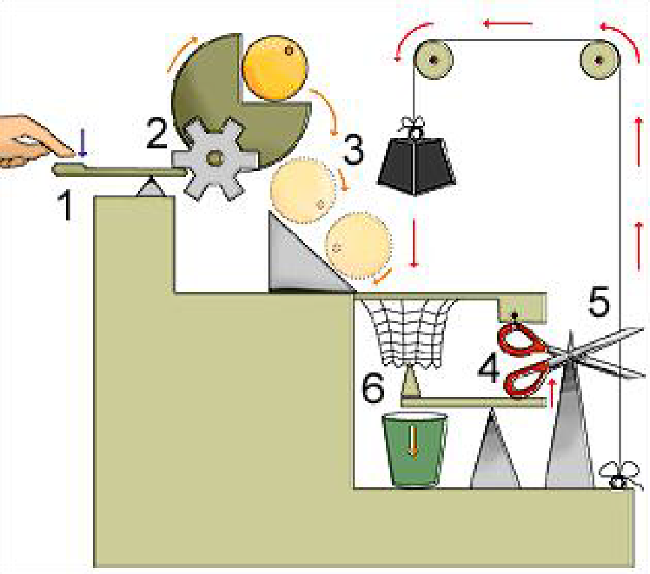

20. Fill in the blanks and color the bar charts below. Mass of the bob is 2.0 kg.
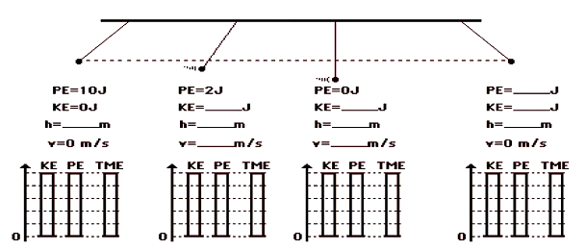

Position 1: h = 0.5 m
Position 2: KE = 8 J, h = .1m, v = 2.8 m/s
Position 3: KE = 10 J. h = 0 m, v = 3.1 m/s
Position 4: PE = 10 J, KE = 0 J, h = 0.5 m

Problems:
- A rope is used to pull a wagon. If the rope makes a 55° to the ground, how much work is done to pull the wagon? If the rope is horizontal to the ground, will the amount of work increase, decrease or stay the same? Explain your answer.

NOT ENOUGH INFO TO ANSWER

- How much gravitational potential energy does a 3kg mass have after it has been lifted 10m?
294 J

- How much kinetic energy is there in a 70kg skateboarder moving 3m/s?

315 J

- A 2kg book falls off a bookshelf 3m high. What is the books speed just before it hits the ground? (Solve the problem 2 different ways)

PE = 58.8 J KE = 58.8 J = ½ mv² v = 7.6 m/s

- A 100kg bungee jumper jumps off a bridge 50m high. His bungee (stretched) is 20 m long.
a. Before he jumps:
    - How much Gravitational Potential Energy does he have? 49,000 J

    - How much Kinetic energy does he have? 0 J

    - What is his total mechanical energy? 49,000 J

b. After he has fallen 20m
    - What is his total mechanical energy? 49,000 J

    - How much Gravitational Potential Energy does he have? 29,400 J; GPE=(100kg x 10 m/s² x 30 m)= 29,400 J

    - How much Kinetic energy does he have? 19,600 J (This is total – GPE at 30 m)
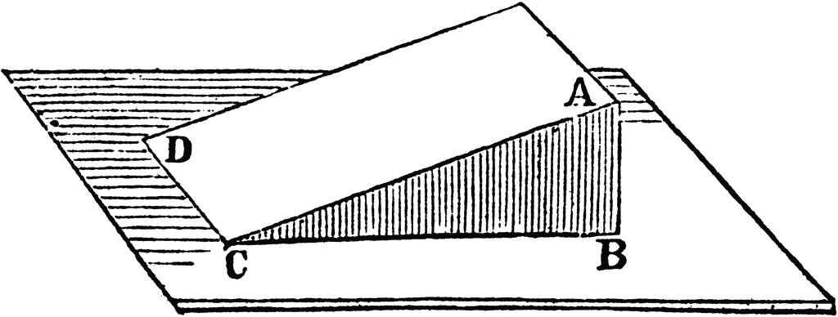
6. A 5.0 kg bock is pushed up the inclined plane in the diagram above. The measurement AB is 6.5 m and the measurement AC is 13.0 m.

a. How much potential energy does the box have when it reaches the top?
GPE = mgh = 5.0 kg x 10 m/s² x 6.5 m = 325 J

b. If the ramp is frictionless, how much force is required to push to box up the ramp?
Work = change in kinetic energy
W = Fd 325 = F(13m) F = 25 N

